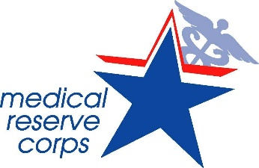

West Texas Medical Reserve Corps
Volunteer Handbook

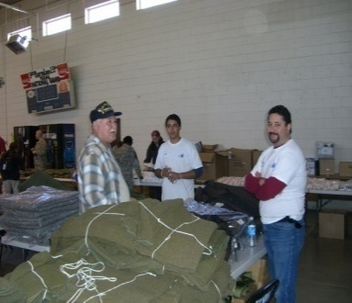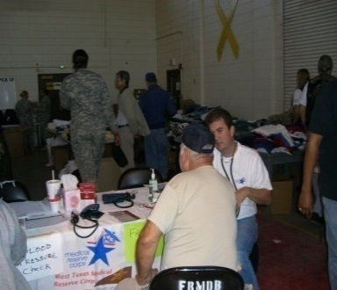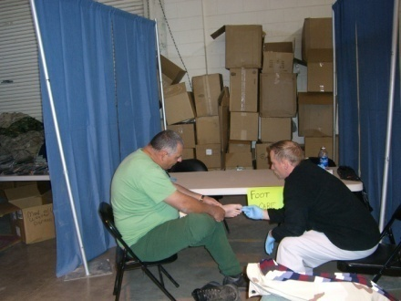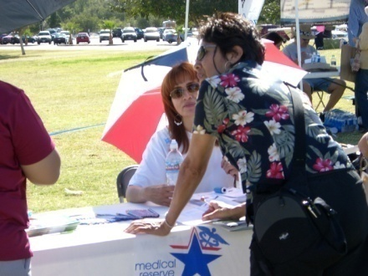

Mission Statement

The mission of the West Texas Medical Reserve Corps is to enhance the regional response capabilities in the event of an emergency, disaster or disease outbreak by providing a coordinated response using locally recruited medical, behavioral health, public health, and health support volunteers. The Medical Reserve Corps volunteers will also work to improve the overall health, preparedness, and well-being of the region.

Goals

- Identify, train, and credential volunteers to assist in response to a disaster, including natural and man-made events (including bio-terrorism).
- Utilize the MRC members to educate the community on preparedness for both terrorist and naturally occurring events (natural disaster, pandemic flu, etc.)
- Identify opportunities for members to assist in response activities for local emergencies or events.
- Promote activities which support the Surgeon General’s priorities.

Geographic Area

The geographic areas to be covered include the counties of El Paso, Hudspeth, and Culberson Counties in Texas. A collaborative working relationship with the Southern New Mexico Medical Reserve Corps is also planned. Future linkages to Juarez, Mexico will be explored as a regional approach. The geographic area includes a large metropolitan border community as well as outlying rural areas. Juarez, Mexico is located just across the river.

Volunteer Handbook
Instructions

- Please read and keep the Handbook. Additional documents/updates will be provided in the future.
- Feel free to make notes and jot down questions…this is your copy.
- Refer to the list of volunteer roles on page 5 and note those that interest you.
- Review training requirements on page 6 and complete your training as soon as possible – additional training announcements are made via e-mail or will be posted on the web at www.westtexasmrc.org .
- Familiarize yourself with the “Volunteer Code of Conduct” in this handbook.
- Your copies of agreements signed during Orientation are included.
Keep these as a part of your handbook for easy reference.

  - HIPPA Confidentiality Agreement
  - Volunteer Confidentiality Agreement
  - Release of Confidential Information
  - Volunteer Risk and Protection from Legal Liability
  - Volunteer Statement/Agreement

DRESS CODE
Dress code for the employees / volunteers of the MRC shall be in accordance with appropriate working conditions in shelter operations or other emergency situations. Volunteer clothing should cover the body. Wear shoes that are comfortable and safe, if dealing directly with animals wear appropriate protection to avoid bites and scratches inflicted by fractious or unruly animals. Medical Scrubs may be worn, if not, please wear your MRC t-shirt. If you do not have an MRC t-shirt please request one.

Background

The West Texas Medical Reserve Corps (West Texas MRC) has been approved and officially registered (November 9, 2006) through the Medical Reserve Corps Program, Office of the Surgeon General. It is also recognized as part of the White House’s USA Freedom Corps initiative and the Department of Homeland Security’s Citizen Corps. Although registered as the West Texas MRC, the long-term intent of the working group is to form a collaborative with the Southern New Mexico Medical Reserve Corps.

Rationale for Establishment of the West Texas Medical Reserve Corps

During the hurricane events of 2005, El Paso received evacuees from both Katrina and Rita and the “Storm 2006” flooding in El Paso and Southern New Mexico. The need to address the region’s needs during such events became apparent. If our community is affected by a bioterrorist attack or a pandemic outbreak affecting hundreds to thousands of people, a reserve corps would help address those medical needs which would overwhelm our traditional ability to respond and provide mass care.

Organizational History:

- Approval of unit in November, 2006.
- Information flyers and interests sheets are being distributed.
- Meetings with governmental, community, and professional agencies/organizations are being conducted. The purpose of these meetings is to generate support and future partnerships as the West Texas Medical Reserve Corps develops.
- Steering committee meetings to develop guidelines and procedures are being held.
- Members are participating in Region VI Medical Reserve Corps Program activities (i.e. conference calls).
- Received permission to utilize National MRC logo.
- Web site developed at www.westtexasmrc.org
- MRC Unit information posted on national web site at Administration for Strategic Preparedness & Response (ASPR)
- In collaboration with United Way and Far West Texas & Southern New Mexico Regional Advisory Council on Trauma received grant from AmeriCorps / Ready for Disasters Preparedness Grant. This supplies two AmeriCorps workers, one Community Outreach Worker and one Information Specialist.
- Received grants from National Association of City and County Health Officials (NACCHO)
- MRC Coordinator attended National Leadership and Training conferences each year.

What is the Medical Reserve Corps (MRC)?

Medical Reserve Corps, or MRC, is a specialized component of Citizen Corps, a national network of volunteers dedicated to ensuring hometown security. Citizen Corps, along with AmeriCorps, Senior Corps and the Peace Corps are all part of the President’s Freedom Corps, which promotes volunteerism and service throughout the nation.
Medical Reserve Corps serves under the office of the United States Surgeon General. The organization was unveiled during President Bush’s 2002 State of the Union Address, in which he asked all Americans to volunteer in support of their country. The primary role of the local MRC unit is to supplement the community emergency response systems already in place.

USA Freedom Corps

AmeriCorps Peace Corps Citizen Corps Senior Corps

Medical Reserve Corps

To learn more about these organizations please the following sites:

USA Freedom Corps: https://www.georgewbushlibrary.gov/research/topic-guides/usa-freedom-corps
AmeriCorps: https://servewashington.wa.gov/programs/americorps
Peace Corps: www.peacecorps.gov
Citizen Corps: https://servewashington.wa.gov/programs/citizen-corps
Senior Corps: https://servewashington.wa.gov/programs/americorps-seniors
Medical Reserve Corps: https://aspr.hhs.gov/MRC/Pages/index.aspx

Role You Play In the MRC

While the services performed by Medical Reserve Corps units around the nation may differ, many have agreed to support critical Homeland Security issues. Ensure medical surge capacity which is the ability to meet the need for an abundance of medical workers during public health emergencies, and assisting with medical special needs sheltering during an event.

Special Needs Shelters

Special Needs Shelters are shelters designed to care for people with special needs, such as:
- People with health/medical conditions requiring nursing observation, assessment and maintenance;
- People with chronic conditions requiring assistance with activities of daily living (ADL) and do not require hospitalization;
- People with regular need for medications and/or regular vital sign readings, and who are unable to do so without regular nursing assistance.
The intent of the shelter is to provide, to the extent possible under emergency conditions, an environment in which the current level of health of the shelterees with special needs can be sustained within the capabilities of available resources. Persons eligible for the Special Needs Shelter have physical conditions that require limited medical/nursing oversight that cannot be accommodated or provided for in a general population shelter

The West Texas Medical Reserve Corps needs volunteers to fill these responsibilities. Volunteers with medical and non-medical backgrounds are encouraged to submit applications. Below are listed volunteer opportunities for individuals who join the West Texas MRC.

Possible Volunteer Roles at an Emergency Point of Delivery (POD) Site or Shelter Site
Any Manager role may be supported by a Coordinator role and a Technician role.
Any Coordinator role may be supported by a Technician role.

Medical Roles:

■ Clinic Manager ■ Screening / Dispensing Technician ■ Crisis Manager Technician
■ Triage Coordinator ■ Dispensing / Vaccination Coordinator ■ Education Technician
■ Triage Technician ■ Physician Consultant ■ Direct Patient Care

Non-Medical Roles:

■ POD Director ■ Documentation Coordinator ■ Administration Manager
■ Safety Manager ■ Translation Technician ■ Runner
■ Facilities Manager ■ Communications / IT Manager ■ Crowd Control
■ Building Technician ■ Security ■ Inventory Control

Volunteer Orientation – introduces volunteers to the West Texas MRC, the local disaster response plan, and other community resources.

Credentialing
Active healthcare professionals are required to provide license number(s), registration, and/or appropriate certification/credentialing information. In the event of an emergency, volunteers will be utilized commensurate with their training and skills. If you do not provide medically acceptable credentials, you will be assigned as a non-medical volunteer. Currently enrolled students must be supervised by a faculty member in order to provide direct patient care. Students not supervised will be assigned as a non-medical volunteer.

Volunteers are requested to register at www.mrc.train.org. This nationally supported website (developed along with the Public Health Foundation) will ask for some personal and professional data. Please make sure to select the organization as West Texas MRC! If you have already completed any disaster-preparedness training, you may enter it into your portfolio. The site provides for a method for tracking training completed through this website as well as adding training completed elsewhere. Use of this site will allow future communication as well as assist our Unit in tracking education. (Note: If already a member of TX TRAIN, there is no need to create a second account. Select “My Account”. Select the “Groups” tab and select “Edit”).
  - Sign up for the mandatory training courses through MRCTrain (www.mrc.train.org ): IS100 Introduction to the Incident Command System and IS700 National Incident Management System if you have not already completed these through another agency. These are FREE courses prepared by FEMA. And you will receive a certificate of completion. Note: There are many, many other very good courses available through this site---free! If you register for the courses through the MRCTrain website, it will track your enrollment and completion for you (and for the West Texas MRC!)
  - If you have not yet done so, check out the following websites for other information:
    - Administration for Strategic Preparedness & Response (ASPR) for multiple resources. Specifically review the August 2019 Medical Reserve Corps Core Competencies.
    - https://servewashington.wa.gov/programs/citizen-corps for information about the Citizen corps program
In addition to the orientation, continuing education courses for all interested MRC volunteers will be offered throughout the year. These courses may include, but are not limited to:
- IS 100 Introduction to the Incident Command System
- IS 700 National Incident Management System
- Basic Disaster Life Support (BDLS)
- Core Disaster Life Support (CDLS)
- Satellite training sessions offered by national and state emergency preparation agencies
- Web-based emergency preparedness training courses
- Other emergency training courses offered in West Texas by local, regional or state organizations.
Volunteer Code of Conduct

Ethics

A volunteer shall:
- Maintain high standards of moral and ethical conduct that includes self-control and responsible behavior. A volunteer must consider the physical and emotional well-being of others and display courtesy and good manners.
- Avoid profane and abusive language and disruptive behavior including behavior that is dangerous to self and others including acts of violence, physical or sexual abuse, or harassment.
- Abstain from transport, storage and/or consumption of alcoholic beverages and/or illegal substances when performing volunteer duties.
- Abstain from illegal activity.
- Avoid conflict of interest situations and refrain from actions that may be so perceived. Volunteers should disclose all potential or actual conflicts of interest as they arise.
- Abstain from the use of audio or video recording equipment, unless authorized, including cameras.
- Report medications taken prior to or during volunteer duties to the MRC Coordinator, or designee.
- Report employment and or address changes to the MRC Coordinator.
- Acknowledge that volunteers can be dismissed or refused acceptance by the West Texas MRC for any reason deemed appropriate by the MRC Director.

Safety

A volunteer shall:
- Put safety first in all volunteer activities.
- Respect and use all equipment appropriately.
- Follow all procedures to the best of one’s ability at all times.
- Promote healthy and safe work practices.
- Recognize and congratulate those volunteers who follow safe and caring practices.
- Take care of self and others.
- Report all injuries, illnesses and accidents to the appropriate staff member.
- Recognize that training is fundamental to everyone’s safety.
- Participation is limited to those age 18 and above

Respect

A volunteer shall:
- Respect the cultures, beliefs, opinions and decisions of others although he/she may not always agree.
- Treat each other with courtesy, sensitivity, tact, consideration and humility.
- Accept the chain of command and respect each other regardless of position.

Medical Reserve Corps Websites

For registration and information:

www.westtexasmrc.org

For registration into the TX Disaster Volunteer Registry

https://texasdisastervolunteerregistry.org

For General Information:

https://aspr.hhs.gov/MRC/Pages/About-the-MRC.aspx

For Internet-based training:

www.mrc.train.org

